Amazon Prime Titles

POWER BI ASSIGNMENT

1. Research and learn the difference between calculated columns and measures.

**Calculated Columns:**

A calculated column in Power BI is a column that is derived from existing data within a dataset through the application of a user-defined formula or expression. These columns are created within the data model and are computed during data refresh or query execution. The values in a calculated column are dynamically generated based on the specified formula and can be used for analysis, visualization, or further calculations within the Power BI report.

**Measures:**

A Power BI measure is a custom calculation you create using DAX. They are used for analyzing or visualizing data. These measures are dynamic, adjusting instantly to user actions like filtering selection specific data points.

1. Calculate Total Titles

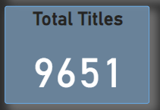

1. Calculate Total Ratings

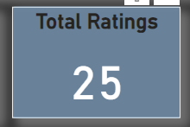

1. Calculate Total Genres

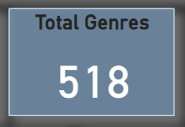

1. Calculate Total Directors

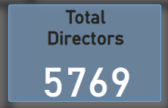

1. Find the Start Date

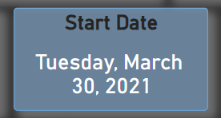

1. Find the End Date

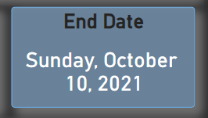

1. Display genres by total shows. Use an appropriate visual type

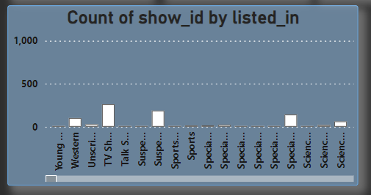

1. Display ratings by total shows. Use an appropriate visual type.

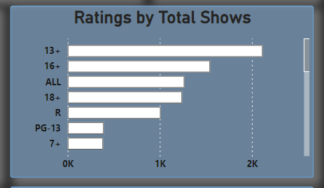

1. Display total shows by country.

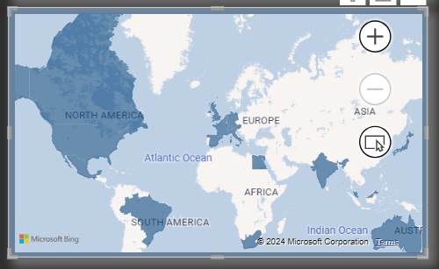

1. Show the distribution of movies and TV shows

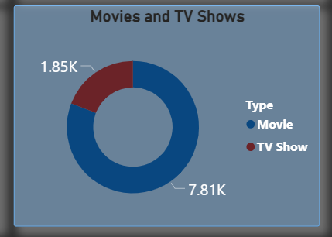

1. Display total shows by release year.

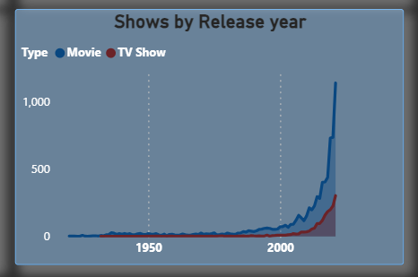

1. Add a heading to your dashboard (use a text box)



1. Add an image/logo to your dashboard.



**Dashboard:**

